**A**

**PROJECT REPORT**

**ON**

**“CAR RENTAL WEBSITE”**

**FOR COURSE**

**RESPONSIVE WEB PAGE DESIGN**

**(4330705)**

**GUIDED BY: PREPARED BY:**

**Ms. A.R.SHAH PATEL JIYAL ANKURBHAI:-226240307042**

**SHAH VANSH ALPESHKUMAR:-226240307060**

**VAIDHYA SAI NARENDRABHAI:- 226240307074**

**JOSHI RUDRANT ASHISHBHAI:- 226240307025**

**DIPLOMA IN 3rd SEMESTER**

**COMPUTER ENGINEERING DEPARTMENT**



**CERTIFICATE**

This is to certify that the micro - project entitled “CAR RENTAL WEBSITE” submitted by **SHAH VANSH ALPESHKUMAR (226240307060) , PATEL JIYAL ANKURBHAI (226240307042) , VAIDHYA SAI NARENDRABHAI (226240307074)** and **JOSHI RUDRANT ASHISHBHAI(226240307025)** towards the partial fulfillment of the requirement for Continuous Assessment (CA) to facilitate integration of Course Outcomes (COs) in Responsive Web Page Design (4330705) is a record of the work carried out by him/her under my guidance and supervision. The work submitted, in my opinion, has to a level required for being accepted for the examination.

| Guided By:  **Ms. A. R. Shah**  Government Polytechnic,  Himatnagar – 380001 | Head of the Department:  **Mrs. M. P. Mehta**  Government Polytechnic,  Himatnagar - 380001 |
| --- | --- |

**TABLE OF CONTENTS**

| No. | Point | Page |
| --- | --- | --- |
| 1 | Brief Description | 1 |
| 2 | Aim of Micro Project | 1 |
| 3 | Course Outcomes Integrated | 1 |
| 4 | Actual Procedure Followed | 1 |
| 5 | Outputs of the Micro-projects | 19 |
| 6 | Actual Resources Used | 20 |
| 7 | Skill Developed/ learning out of this Micro-Project | 21 |

**1.0 Brief Description**

The micro-project for Responsive Webpage Design (RWPD) was like crafting a cool website using Bootstrap, HTML, and JavaScript. It's all about making a website look good on phones and computers. My site is all about renting fancy sports and luxury cars and looks great on any device, thanks to Bootstrap. I learned to use GitHub to share my work with others and put my site on the internet for the first time. It was a bit tricky, like learning a new dance, but I got the hang of it. The project taught me how to make sure the website looks good on small and big screens.

**2.0 Aim of Micro Project**

The aim of my micro-project in Responsive Webpage Design is to make a website that looks good on phones and computers. I want to use what I learned about HTML, Bootstrap, and JavaScript to create a site where people can easily rent cool sports and luxury cars. I also want to show that I can make the website work on different devices, especially on mobile phones. By using GitHub, I'll learn how to share my work with others and put my site on the internet. The goal is to make a website that's easy for people to use.

**3.0 Course Outcomes Integrated**

CO1) prepare environment for bootstrap framework for first time use

CO2) build different web page layout adhering to all platform and size

CO3) apply reusable bootstrap components to design effective user friendly web page

CO4) develop interactive features rich web pages using bootstrap jquery plug-ins

**4.0 Actual Procedure Followed.**

1. Source Code : “ <https://github.com/JiyalPatel/RwpdProject> ” [(Source Code)](https://github.com/JiyalPatel/RwpdProject)

* Project Members Github Account

Jiyal Patel - [Link](https://github.com/JiyalPatel)

Vansh Shah - [Link](https://github.com/ShahVansh)

Sai Vidhya - [Link](https://github.com/saivaidhya12)

Rudrant Joshi - [Link](https://github.com/raj53155315)

1. Live Site Git URL : “ <https://jiyalpatel.github.io/RwpdProject/> ” [(Click Here)](https://jiyalpatel.github.io/RwpdProject/)
2. Source code :

<!DOCTYPE html>

<html lang="en">

<head>

<meta charset="UTF-8">

<meta name="viewport" content="width=device-width, initial-scale=1.0">

<title>Car for Rent</title>

<link href="https://cdn.jsdelivr.net/npm/bootstrap@5.3.2/dist/css/bootstrap.min.css" rel="stylesheet" integrity="sha384-T3c6CoIi6uLrA9TneNEoa7RxnatzjcDSCmG1MXxSR1GAsXEV/Dwwykc2MPK8M2HN" crossorigin="anonymous">

<link rel="stylesheet" href="https://cdnjs.cloudflare.com/ajax/libs/font-awesome/6.5.1/css/all.min.css" integrity="sha512-DTOQO9RWCH3ppGqcWaEA1BIZOC6xxalwEsw9c2QQeAIftl+Vegovlnee1c9QX4TctnWMn13TZye+giMm8e2LwA==" crossorigin="anonymous" referrerpolicy="no-referrer" />

<style>

*{

margin: 0%;

padding: 0%;

}

.navigation{

background-color: rgba(128, 128, 128, 0.224);

position: fixed;

}

img.mr {

height: 60px;

}

#bb {

border-bottom: 3px solid rgba(128, 128, 128, 0);

}

#bb:hover,#bb.active{

border-bottom: 3px solid rgb(255, 98, 0);

}

#bb a.nav-link:hover, .navbar-nav .nav-link.active {

color: rgb(255, 98, 0) !important;

font-weight: 500;

font-size: 15px;

}

.logo-area{

width: 25%!important;

}

.navbar-nav {

width: 100%;

}

#hover {

border: 1px solid rgb(255, 98, 0);

float: left;

padding: 11px 22px;

color: #fff!important;

background: rgb(255, 98, 0);

text-transform: capitalize;

letter-spacing: 0.6px;

}

li.right-btn {

margin-left: auto !important;

}

#hover:hover {

background: #fff;

color: rgb(255, 98, 0) !important;

border: 1px solid rgb(255, 98, 0);

}

.banner-area{

background-color: rgba(128, 128, 128, 0.124);

padding-top: 110px;

}

.banner-text{

max-width: 350px;

padding-top: 150px;

padding-left: 30px;

}

.banner-text h1{

font-size: 60px;

font-weight: 700;

letter-spacing: 1.5px;

line-height: 80px;

}

.banner-text span{

color: rgb(255, 98, 0);

}

.container {

width: 100%;

max-width: 1170px;

}

.color1 {

background-image: url(img/Car\ Website1@222.png);

background-position: top center;

background-size: cover;

background-repeat: no-repeat;

height: 586px;

}

.Ride{

text-align: center;

padding-top: 90px;

padding-bottom: 50px;

}

.Ride p{

font-weight: 500;

font-size: 16px;

}

.Ride h2{

font-weight: 700;

font-size: 35px;

}

.section{

background-color: rgba(255, 98, 0, 0.14);

}

.rent p{

/* max-width: 250px; */

text-align: center;

padding: 10px;

}

.rent i{

margin-top: 50px;

font-size: 30px;

border: 3px solid rgb(255, 98, 0);

border-radius: 50px;

color: rgb(255, 98, 0);

width: 60px;

height: 60px;

line-height: 40px;

}

.rent h5{

margin: 20px;

}

.Service1{

background-color: #fff;

}

.Service{

margin: auto;

padding-top: 100px;

padding-bottom: 70px;

}

.Service p{

font-weight: 500;

font-size: 16px;

}

.Service h2{

font-weight: 700;

font-size: 35px;

max-width: 400px;

margin: auto;

padding-bottom: 30px;

}

.part{

background-color: rgba(255, 98, 0, 0.14);

border-radius: 10px;

height: 400px;

padding-left: 12px;

}

.part img{

width: 350px;

height: 230px;

margin-top: 10px;

border-radius: 10px;

}

.model{

margin: 10px 5px;

border: 1px solid rgba(128, 128, 128, 0.873);

width: 54px;

padding: 4px 9px;

border-radius: 6px;

font-size: 14px !important;

color: rgba(128, 128, 128, 0.858);

}

.part h6{

font-size: 22px;

margin: 7px 5px;

}

.price{

color: rgb(255, 98, 0);

font-size: 17px !important;

margin: 10px 5px;

}

.part span{

color: rgba(128, 128, 128, 0.873);

font-size: 14px;

}

.part a{

background-color: rgb(255, 98, 0);

text-decoration: none;

color: #fff;

padding: 5px 139px;

border-radius: 6px;

}

.about{

color: rgb(255, 98, 0);

}

.cir{

border-radius: 50%;

}

#About{

padding-top: 200px;

}

.but{

background-color: rgb(255, 98, 0);

padding: 10px;

border-radius: 10px;

color: white;

}

.btn-floating {

border-radius: 50%;

background-color: rgb(255, 98, 0);

color: #fff;

}

</style>

</head>

<body>

<header>

<div class="container-fluid navigation">

<div class="container">

<nav class="navbar navbar-expand-lg">

<a class="navbar-brand logo-area" href="#"><img class="mr mr-3 object-fit-cover" src="img/jeep.png"></a>

<button class="navbar-toggler" type="button" data-bs-toggle="collapse" data-bs-target="#navbarSupportedContent" aria-controls="navbarSupportedContent" aria-expanded="false" aria-label="Toggle navigation">

<span class="navbar-toggler-icon"></span>

</button>

<div class="collapse navbar-collapse" id="navbarSupportedContent">

<ul class="navbar-nav mb-2 mb-lg-0">

<li class="nav-item m-3">

<a class="nav-link active fs-7 fw-bold text-dark" id="bb" href="#">Home</a>

</li>

<li class="nav-item m-3" id="bb">

<a class="nav-link fs-7 fw-bold text-dark" href="#Ride">Ride</a>

</li>

<li class="nav-item m-3" id="bb">

<a class="nav-link fs-7 fw-bold text-dark" href="#Service">Services</a>

</li>

<li class="nav-item m-3" id="bb">

<a class="nav-link fs-7 fw-bold text-dark" href="#About">About</a>

</li>

<li class="nav-item m-3" id="bb">

<a class="nav-link fs-7 fw-bold text-dark" href="#Review">Reviews</a>

</li>

<li class="nav-item right-btn pt-3">

<a class="nav-link fs-7 fw-bold active rounded" id="hover" href="#Contact">Contact Us</a>

</li>

</ul>

</div>

</nav>

</div>

</div>

</header>

<section class="container-fluid banner-area">

<div class="container">

<div class="row">

<div class="col-sm-6">

<div class="banner-text">

<h1><span>Looking</span> to rent a car</h1>

<p class="py-2">Lorem ipsum dolor, sit amet consectetur adipisicing elit. Odit hic modi optio.</p>

<img src="img/512x512.png" width="150px" height="50px">

<img src="img/ios.png" width="150px" height="50px">

</div>

</div>

<div class="col-sm-6 color1">

<div class="banner-img">

</div>

</div>

</div>

</div>

</section>

<section class="container-fluid section pt-3" id="Ride">

<div class="container Ride">

<P>HOW ITS WORK</P>

<h2>Rent With 3 Easy Steps</h2>

<div class="row">

<div class="col-sm-4 rent">

<i class="fa-solid fa-location-dot p-2"></i>

<h5>Choose A Location</h5>

<P>Lorem ipsum dolor sit amet consectetur adipisicing elit. Maiores accusantium corporis, harum fuga consectetur deleniti doloremque sint dolore veniam quisquam.</P>

</div>

<div class="col-sm-4 rent">

<i class="fa-solid fa-calendar-check p-2"></i>

<h5>Pick-Up Date</h5>

<P>Lorem ipsum dolor sit amet consectetur adipisicing elit. Maiores accusantium corporis, harum fuga consectetur deleniti doloremque sint dolore veniam quisquam.</P>

</div>

<div class="col-sm-4 rent">

<i class="fa-solid fa-car p-2"></i>

<h5>Book A Car</h5>

<P>Lorem ipsum dolor sit amet consectetur adipisicing elit. Maiores accusantium corporis, harum fuga consectetur deleniti doloremque sint dolore veniam quisquam.</P>

</div>

</div>

</div>

</section>

<section class="container-fluid Service1 " id="Service">

<div class="container Service">

<p class="text-center">BEST Services</p>

<h2>Explore Out Top Deals From Top Rated Dealers</h2>

<div class="row">

<div class="col-lg-4">

<div class="part">

<img src="img/car-7.jpg">

<P class="model">2022</P>

<h6>Lamborghini SVJ 63</h6>

<p class="price">$6948 | $579 <span>/month</span></p>

<a href="#">Rent Now</a>

</div>

</div>

<div class="col-lg-4">

<div class="part">

<img src="img/car-1.jpg">

<P class="model">2023</P>

<h6>Lamborghini Huracan</h6>

<p class="price">$6660 | $555 <span>/month</span></p>

<a href="#">Rent Now</a>

</div>

</div>

<div class="col-lg-4">

<div class="part">

<img src="img/car-3.jpg">

<P class="model">2021</P>

<h6>Lamborghini Urus</h6>

<p class="price">$6132 | $511 <span>/month</span></p>

<a href="#">Rent Now</a>

</div>

</div>

</div>

<div class="row py-2">

<div class="col-sm-4">

<div class="part">

<img src="img/bmw.jpg">

<P class="model">2023</P>

<h6>BMW X4</h6>

<p class="price">$4284 | $357 <span>/month</span></p>

<a href="#">Rent Now</a>

</div>

</div>

<div class="col-sm-4">

<div class="part">

<img src="img/car-5.jpg">

<P class="model">2021</P>

<h6>LaFerrari</h6>

<p class="price">$5472 | $456 <span>/month</span></p>

<a href="#">Rent Now</a>

</div>

</div>

<div class="col-sm-4">

<div class="part">

<img src="img/car-4.jpg">

<P class="model">2020</P>

<h6>Porche 911 Boxster</h6>

<p class="price">$3876 | $323 <span>/month</span></p>

<a href="#">Rent Now</a>

</div>

</div>

</div>

</div>

</section>

<section class="container-fluid mb-5" id="About">

<div class="container">

<div class="row">

<!-- Image Section -->

<div class="col-md-6">

<img src="img/about.png" alt="" class="img-fluid">

</div>

<!-- Text Section -->

<div class="col-md-6">

<h2 class="about">ABOUT US</h2>

<p>Lorem, ipsum dolor sit amet consectetur adipisicing elit. Repellendus quia quam numquam placeat id ratione sed aut nostrum? Aperiam provident ipsam fuga dolores iste quaerat sunt repellat delectus minima! Similique, alias aut, inventore, totam ratione exercitationem autem vel suscipit reiciendis aliquid iste dolorem soluta a hic accusamus quaerat natus eligendi?</p>

<br>

<P>Lorem ipsum dolor sit amet consectetur adipisicing elit. Deserunt fugiat quidem magnam error placeat, ad quas!</P>

<button type="button" class="btn btn-primary">Learn More</button>

</div>

</div>

</div>

</section>

<section class="container pt-5 mb-5" id="Review">

<div class="container">

<div class="row mt-5">

<p class="text-center m-0">REVIEWS</p>

<h2 class="text-center fw-bold mb-5">Whats Our Customer Say</h2>

<!-- Review 1 -->

<div class="col-md-4 text-center">

<img src="img/mark.jpg" alt="" class="cir mb-3" width=100 height=100>

<h5>Mark Bob</h5>

<!-- Star Ratings -->

★★★★☆

<!-- Review Text -->

<p>Lorem ipsum dolor sit amet, consectetur adipiscing elit, sed do eiusmod tempor incididunt ut labore et dolore magna aliqua. Ac tortor dignissim convallis aenean et. Ipsum nunc aliquet bibendum enim. Mi eget mauris pharetra et. Ac tincidunt vitae semper quis lectus nulla at. Urna id volutpat lacus laoreet. Amet nisl purus in mollis nunc. Gravida rutrum quisque non tellus orci. Mi quis hendrerit dolor magna eget est lorem ipsum. A cras semper auctor neque. Sem fringilla ut morbi tincidunt augue interdum velit euismod. Semper feugiat nibh sed pulvinar. Arcu non odio euismod lacinia at quis. Id diam vel quam elementum pulvinar etiam. Urna et pharetra pharetra massa. Urna cursus eget nunc scelerisque viverra mauris in aliquam sem. Ultrices dui sapien eget mi proin sed libero enim sed. Facilisis mauris sit amet massa vitae. Lectus arcu bibendum at varius vel pharetra. Duis at tellus at urna condimentum mattis.</p>

</div>

<!-- Review 2 -->

<div class="col-md-4 text-center">

<img src="img/lilly.jpg" alt="" class="cir mb-3" width=100 height=100>

<h5>Lilly Adam</h5>

★★★★☆

<!-- Review Text -->

<p>Lorem ipsum dolor sit amet consectetur adipisicing elit. Natus maiores sint nesciunt perferendis. Vero temporibus aperiam debitis eligendi quo optio?</p>

</div>

<!-- Review 3 -->

<div class="col-md-4 text-center">

<img src="img/jon.jpg" alt="" class="cir mb-3" width=100 height=100>

<h5>Jon Snow</h5>

★★★★☆

<!-- Review Text -->

<p>Lorem ipsum dolor sit amet consectetur adipisicing elit. Natus maiores sint nesciunt perferendis. Vero temporibus aperiam debitis eligendi quo optio?</p>

</div>

</div>

</div>

</section>

<footer class="bg-dark text-white py-5 pt-5" id="Contact">

<div class="container">

<div class="row">

<div class="col-md-4 mb-4">

<h5 class="text-white mb-4">Contact Us</h5>

<form>

<div class="mb-3">

<label for="name" class="form-label text-white">Name</label>

<input type="text" class="form-control" id="name" placeholder="Enter your name" required>

</div>

<div class="mb-3">

<label for="email" class="form-label text-white">Email address</label>

<input type="email" class="form-control" id="email" placeholder="Enter your email" required>

</div>

<div class="mb-3">

<label for="message" class="form-label text-white">Message</label>

<textarea class="form-control" id="message" rows="3" placeholder="Enter your message" required></textarea>

</div>

<button type="button" class="btn but" id="submitbtn">Send Message</button>

</form>

</div>

<div class="col-md-4 mb-4">

<h5 class="text-white mb-4">Quick Links</h5>

<ul class="list-unstyled text-white">

<li><a href="#">Home</a></li>

<li><a href="#Ride">Ride</a></li>

<li><a href="#Service">Services</a></li>

<li><a href="#About">About</a></li>

<li><a href="#Review">Reviews</a></li>

</ul>

</div>

<div class="col-md-4 mb-4">

<h5 class="text-white mb-4">Follow Us</h5>

<a href="#" class="btn btn-floating m-1"><i class="fab fa-facebook-f"></i></a>

<a href="#" class="btn btn-floating m-1"><i class="fab fa-twitter"></i></a>

<a href="#" class="btn btn-floating m-1"><i class="fab fa-instagram"></i></a>

<a href="#" class="btn btn-floating m-1"><i class="fab fa-linkedin-in"></i></a>

</div>

</div>

</div>

<div class="container text-center text-white mt-4 py-3">

<p>&copy; 2023 Car Rental. All rights reserved.</p>

</div>

</footer>

<script src="https://cdn.jsdelivr.net/npm/bootstrap@5.3.2/dist/js/bootstrap.bundle.min.js" integrity="sha384-C6RzsynM9kWDrMNeT87bh95OGNyZPhcTNXj1NW7RuBCsyN/o0jlpcV8Qyq46cDfL" crossorigin="anonymous"></script>

<script>

document.getElementById("submitbtn").addEventListener("click", () => {

alert("Your Message Has Been Submited. We Will Contact You Soon...")

});

</script>

</body>

</html>

**5.0 Outputs of the Micro-projects**

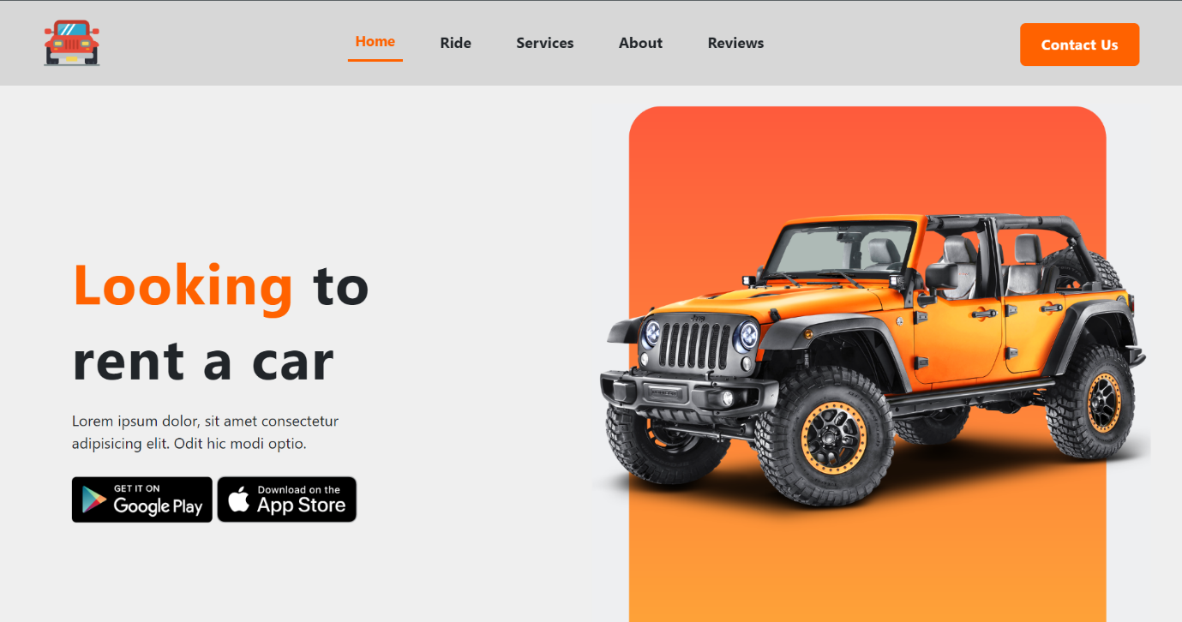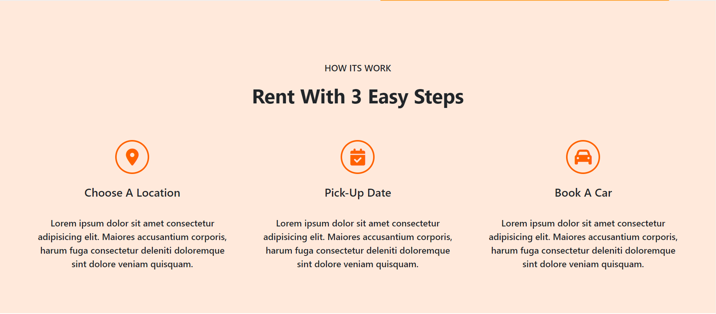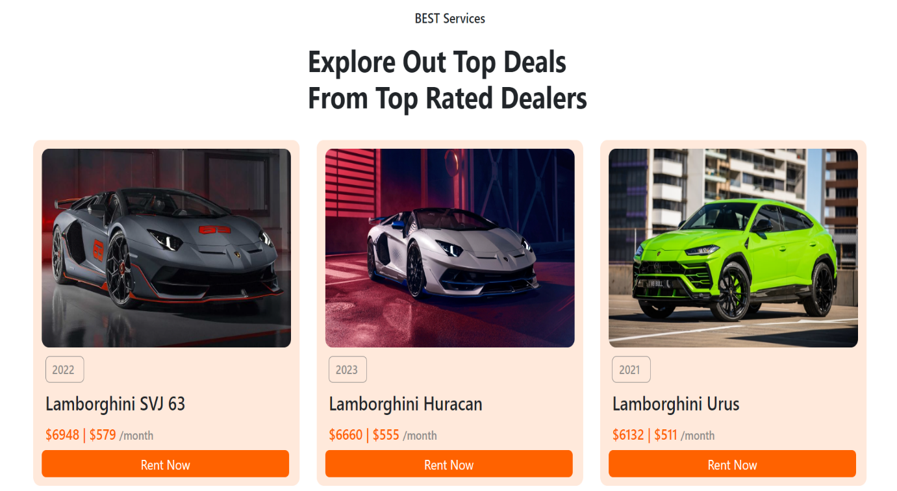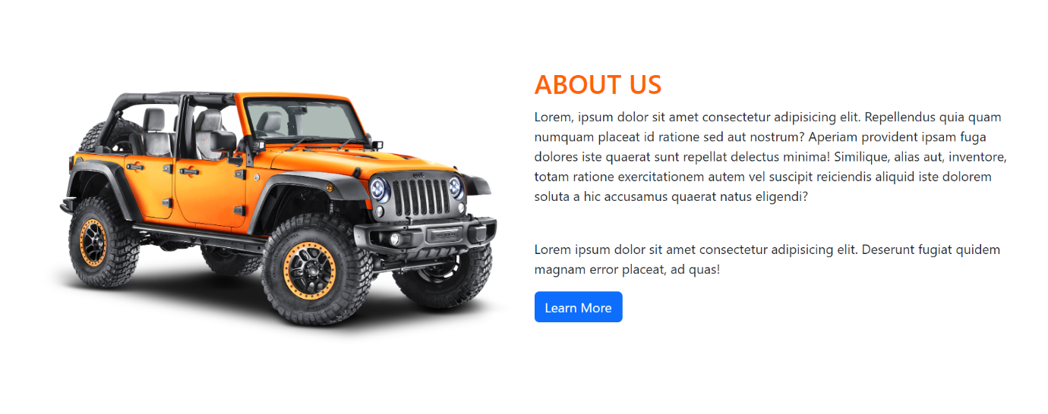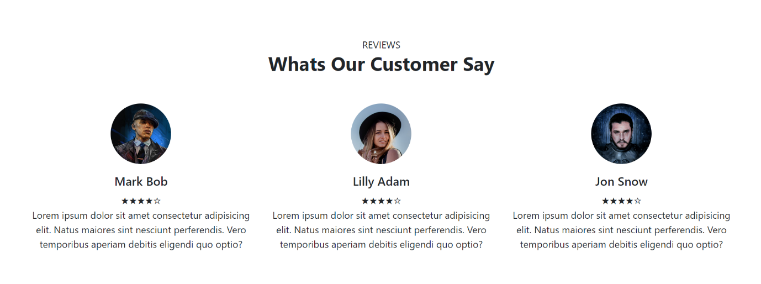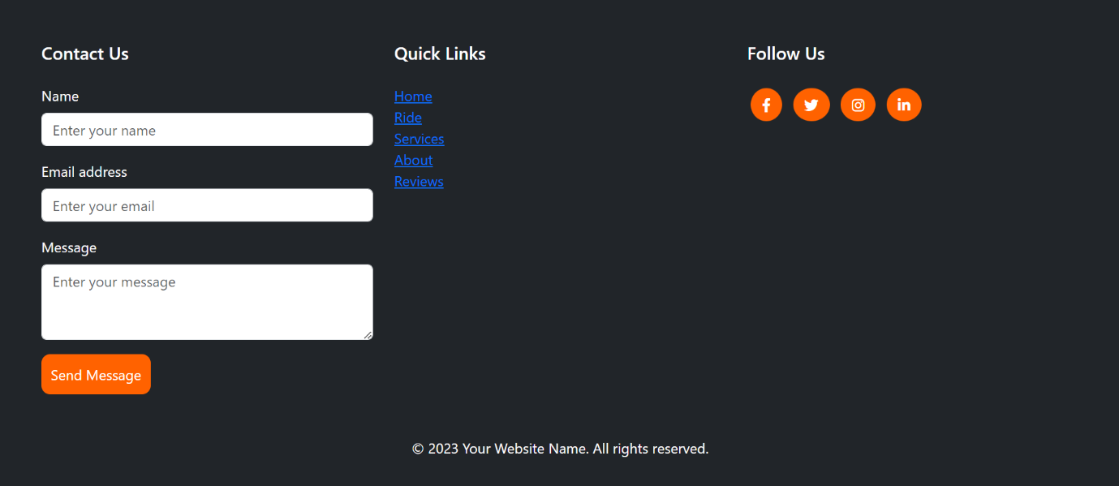

**6.0 Actual Resources Used**

| **Sr. No** | **Name of Resource/material** | **Remarks** |
| --- | --- | --- |
| **1** | **https://www.youtube.com** | Good |
| **2** | **https://getbootstrap.com** | Good |
| **3** | **https://chat.openai.com/** | Good |

**7.0 Skill Developed/ learning out of this Micro-Project**

1. HTML Proficiency Enhancement:

* Develop a strong command of HTML, the foundational language for constructing the structure of web pages.
* Gain expertise in organizing content and establishing a logical hierarchy within the website.

1. Utilization of Bootstrap for Responsive Design:

* Incorporate Bootstrap, a widely-used front-end framework, to achieve proficiency in responsive web design.
* Ensure a seamless and visually appealing user experience across various devices and screen sizes through Bootstrap's pre-built components and responsive grid system.

1. Simplified Interface Development:

* Utilize Bootstrap's features to create a user-friendly interface without delving extensively into intricate CSS styling.
* Leverage the pre-built components and grid system to streamline the interface development process.

1. Emphasis on Clean HTML Markup:

* Understand the importance of clean and semantic HTML markup for effective web development.
* Recognize the significance of external libraries like Bootstrap in optimizing the development workflow.

1. Application of Design Principles:

* Implement key design elements such as navigation menus, car listings, and reservation forms to enhance skills in structuring and styling web content effectively.

1. Handling Dynamic Elements:

* Navigate the inclusion of dynamic elements, particularly forms for user input.
* Potentially integrate JavaScript to add layers of interactivity, broadening the understanding of collaborative technologies in functional user experience.

1. Comprehensive Learning Opportunity:

* Engage in a holistic learning experience covering web design principles, responsive development, and the practical application of front-end frameworks.
* Build a car rental website as a real-world project, applying theoretical knowledge to create a functional and aesthetically pleasing online platform.